Your Paper's Title Starts Here: Please
use Times New Roman, 14 pt, bold, centered

First Author*^{1, a}, Second Author^{2,b}, Last Author^{3,c}
¹Full address of first author’s institution, including country
²Full address of second author’s institution, including country
³List all distinct addresses in the same way
ªemail, ^{b}email, ^{c}email
For the rest of the paper, please use Times Roman (Times New Roman) 11, The number of pages for full paper is 5-7 pages.
Abstract. This template explains and demonstrates how to prepare your full paper for the Proceedings of the 6th International Workshop on UI GreenMetric World Unievrsity Rankings (IWGM 2020). The best is to read these instructions and follow the outline of this text.
Please make the page settings of your word processor, one-column page setup, should be typed using 11 pt Times New Roman or Computer Modern font, paragraph single-spaced on standard A4 paper (297×210 mm; or 8×11”), leaving a full 2.5 cm (0.98”) margin on all sides. They should be suitable for direct reproduction (no faxes please). The authors’ names (normal font, 11 pt, centered) and affiliations (italic, 11 pt, centered). Please put * after the name for the presenting author. Do not use page numbering.

Keywords: List 4-5 keywords covered in your paper. These keywords will also be used by the publisher to produce a keyword index.

- Introduction
All manuscripts must be in English, also the table and figure texts, otherwise we cannot publish your paper.
Please keep a second copy of your manuscript in your office. When receiving the paper, we assume that the corresponding authors grant us the copyright to use the paper for the Proceedings in question. Should authors use tables or figures from other Publications, they must ask the corresponding publishers to grant them the right to publish this material in their paper.
Use italic for emphasizing a word or phrase. Do not use boldface typing or capital letters except for section headings (cf. remarks on section headings, below).

- Organization of the Text
  - Section Headings
The section headings are in boldface capital and lowercase letters. Second level headings are typed as part of the succeeding paragraph (like the subsection heading of this paragraph).
Page Numbers. Do not number your paper. Tables (refer with: Table 1, Table 2, ...) should be presented as part of the text, but in such a way as to avoid confusion with the text. A descriptive title should be placed above each table. Units in tables should be given in square brackets [meV]. If square brackets are not available, use curly {meV} or standard brackets (meV).

Table 1. Title of table 1
Text | Text | Text | Text

Special Signs. for example, α γ μ Ω () ≥ ± ● Γ {110} should always be written in with the fonts Times New Roman or Arial, especially also in the figures and tables.
Macros. Do not use any macros for the figures and tables. (We will not be able to convert such papers into our system).
Language. All text, figures and tables must be in English.
Figures. Figures (refer with: Fig. 1, Fig. 2, ...) also should be presented as part of the text, leaving enough space so that the caption will not be confused with the text. The caption should be self-contained and placed below or beside the figure. Generally, only original drawings or photographic reproductions are acceptable. Only very good photocopies are acceptable. Utmost care must be taken to insert the figures in correct alignment with the text. Half-tone pictures should be in the form of glossy prints. If possible, please include your figures as graphic images in the electronic version. For best quality the pictures should have a resolution of 300 dpi (dots per inch).

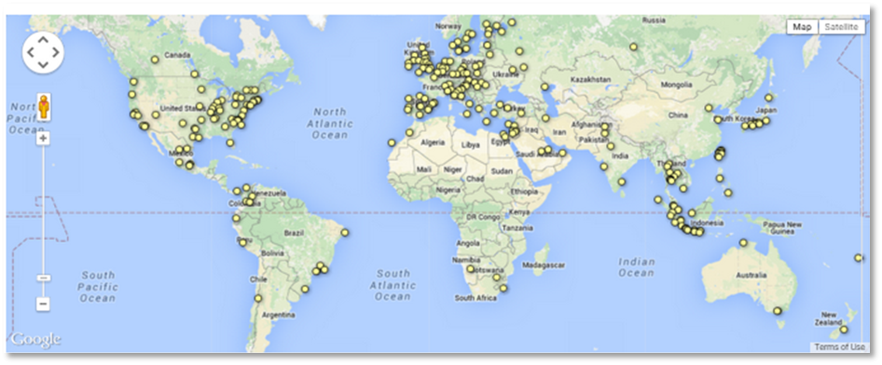
Figure 1. Title of figure 1
Color figures are welcome for the online version of the Proceedings. Generally, these figures will be reduced to black and white for the print version. The author should indicate on the checklist if he wishes to have them printed in full color and make the necessary payments in advance.
Equations. Equations (refer with: Eq. 1, Eq. 2, ...) should be centered. There should be one line of space above the equation and one line of space below it before the text continues. The equations have to be numbered sequentially, and the number put in parentheses at the right-hand edge of the text.

c² = a² + b² (1)

- Literature References
References are cited in the text just by square brackets [1]. (If square brackets are not available, slashes may be used instead, e.g. /2/.) Two or more references at a time may be put in one set of brackets [3, 4]. The references are to be numbered in the order in which they are cited in the text and are to be listed at the end of the contribution under a heading References, see the example below.

- Summary/ Concluding Remarks
Please write in this section the findings, conclusion along with the contribution and or implication for the near future research, educational, program, activities, etc.

References (an example)
[1] Maric, P.F., Meier, S.K., 1992. Theoretical Methods in Higher Education Institution. Education Journal, Volume 83-87, pp. 119-128
[2] Green, M.A., 1987. High Efficiency in Higher Education Institution. University Publications, Switzerland
[3] Mishing, Y., 2004. Learning Processes in Developing Sustainable Campus, edited by D. Gupta Noyes Publications/William Andrew Publising, Norwich, NY, in press
[4] Ong, J.T., Dawley, P.G., 2013. High Efficiency of Wastewater Treatment. In: The Proceedings of the 1st International Workshop on UI GreenMetric. Universitas Indonesia
[6] Clem, M., Rodriguez, J.A., Ashley, C.S., 2001. Annual Report of Sustanability Campus. Name of University
[7] UI GreenMetric, 2014. UI GreenMetric World University ranking. Available online at http://greenmetric.ui.ac.id/, accessed on date, month, year

